Introduction to Multiple Linear Regression
After understanding Simple Linear Regression, the next step is to explore a more advanced technique: Multiple Linear Regression.
While Simple Linear Regression predicts an outcome using one independent variable, Multiple Linear Regression allows us to use multiple independent variables to make predictions.

The Multiple Linear Regression Equation
The general equation for Multiple Linear Regression is:
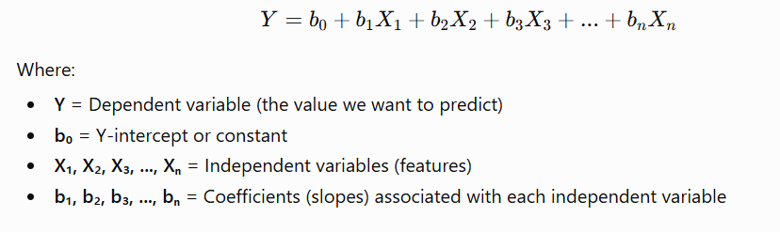

Difference Between Simple and Multiple Linear Regression
The main difference is the number of independent variables.

Simple Linear Regression
Uses only one predictor:
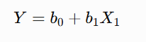
Example:
Predicting salary based only on years of experience.

Multiple Linear Regression
Uses multiple predictors:
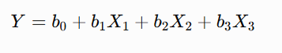

Example:
Predicting salary based on:
- Years of experience
- Education level
- Job position
- Location

Understanding the Coefficients
In Multiple Linear Regression, each independent variable has its own coefficient.
The coefficient represents how much the dependent variable changes when that particular feature increases by one unit, while keeping all other variables constant.
For example:
- A positive coefficient means the feature increases the predicted outcome.
- A negative coefficient means the feature decreases the predicted outcome.

Example: Predicting Potato Yield
Let's return to our farming example.
Suppose we want to predict potato production based on three different factors:
- Amount of nitrogen fertilizer used
- Average temperature during the season
- Amount of rainfall received
The regression equation could look like:

Interpreting the Equation

Intercept: 8 Tons
The value 8 tons represents the predicted potato yield when all input variables are zero.
This is the baseline value of the model.

Fertilizer Coefficient: 3 Tons per Kilogram
The coefficient for fertilizer is:
333
This means:
For every additional kilogram of nitrogen fertilizer used, potato production increases by approximately 3 tons, assuming temperature and rainfall remain unchanged.
This is a positive relationship.

Temperature Coefficient: -0.54 Tons per Degree Celsius
The temperature coefficient is:
−0.54-0.54−0.54
This means:
For every 1°C increase in temperature, potato production decreases by 0.54 tons, assuming fertilizer and rainfall remain constant.
The negative value indicates an inverse relationship.
Higher temperatures may reduce potato yield.

Rainfall Coefficient: 0.04 Tons per Millimeter
The rainfall coefficient is:
0.040.040.04
This means:
Every additional millimeter of rainfall increases the predicted potato yield by 0.04 tons, assuming other factors remain unchanged.
This represents a positive relationship between rainfall and production.

Why Use Multiple Linear Regression?
Real-world problems are rarely influenced by only one factor.
For example, potato production depends on many environmental conditions:
- Fertilizer usage
- Temperature
- Rainfall
- Soil quality
- Sunlight
- Irrigation
Using multiple variables allows the model to capture more complex relationships and often improves prediction accuracy.

Key Takeaways
- Multiple Linear Regression extends Simple Linear Regression by using multiple independent variables.
- Each feature has its own coefficient that determines its influence on the prediction.
- Positive coefficients increase predictions, while negative coefficients decrease them.
- The model can capture relationships involving several factors simultaneously.
- Multiple Linear Regression is useful for many real-world prediction problems.
- Unlike Simple Linear Regression, it can analyze more complex situations involving multiple influencing variables.

